Central Iowa Paddlers
Volume 7 Issue 2 May 2003

This newsletter is a publication of the Central Iowa Paddlers, an informal group of paddlesport enthusiasts. The mission of the club is to share information, promote recreation opportunities and paddlesport safety, and encourage care of our aquatic resources. The group includes new and experienced paddlers with canoes and kayaks of all kinds. Pass the word!

MEANDERINGS

The spring paddling season has proven to be great fun. There’s been plenty of rain and we’ve been able to float down streams that are usually too shallow to paddle. One group of paddlers in particular gets really pumped this time of year. The whitewater crowd has coalesced and we’re hearing lots from them. I’ve included some of their stories so you’ll know that Iowa has more than Class I water.
The sport of paddling continues to evolve. On a recent Upper Iowa River trip I camped next to a big group of paddlers from around the Midwest who met on-line and planned the trip prior to meeting one another in person. My friend Vic shares the following website, http://www.paddling.net/, and says, “You might find the message boards helpful and amusing. Click on the message boards link on the left side of the page. This will send you to a page that will list the five message boards for this web site. Check out the “Getting Together & Going Paddling” forum.”
This issue truly reflects our mission to share information, promote recreation opportunities and paddlesport safety, and encourage care of our aquatic resources. It is packed with your stories – I’ve enjoyed reading them and I hope you all do, too. Have fun out there, be safe, and thanks for picking up those beer cans and tires!
- Robin Fortney, Editor
CIP LEADERSHIP CHANGE IN THE WORKS

As many of you know, I am planning to retire from my role as chair of the Central Iowa Paddlers at the end of the year. A number of you have said you’d like to keep our virtual group going, and you would be willing to take on some additional responsibility for that to happen.
Let’s make our traditional fall party a continuity planning event. Please mark your calendar now for Sunday afternoon, October 19th. It would be great to have all your thoughts and comments on the table as we plan for the future.

JUNE 7 - WATERSHED UNIVERSITY

Join us this Saturday for the Big Kickoff Event for Watershed University in Des Moines if you enjoy paddling, know the importance of good water quality and appreciate trash-free rivers, or want to work alongside Chad Pegracke (winner of the 2002 Jefferson Award, America's version of the Nobel Prize for Public Service, along with Rudolph Giuliani, Bill and Melinda Gates, and Lilly Tartikoff) and local elected officials to tidy up a section of the Des Moines River in downtown Des Moines. Check out www.watershedu.org or more information.
Plan to meet at Des Moines Prospect Park boat ramp at 8 a.m. Prospect Park can be accessed from Hickman Road just west of 6th Avenue or ML King Parkway about 4 blocks north of Hickman Road. Chad Pegracke and the dignitaries will be on hand to clean up the river from Prospect Park to Birdland Marina.
Following the cleanups, Watershed U volunteers are invited to gather at Gray s Lake. Here, the orientation continues from 10 a.m. to 2 p.m., and the fun is open to the public! Planned activities range from sophisticated orienteering exercises to the fun of Recycling Olympics, Watershed Disc Golf and fishing for pollutants (for the younger volunteers). Conservation, neighborhood and business groups will be operating booths for fun and information with many, many other events on the drawing board for the Gray s Lake site as well. The event is open to the public, and they will have FOOD for everyone and great T-shirts for the volunteers.

IOWA WATER TRAIL ASSOCIATION NEWS from Gerry Rowland

I hope you had a good earth day. I spent time picking up at the Harriet Street (Des Moines) boat ramp, which is the access point above Yellow Banks County Park. I noticed that Harriet Street was in bad shape Sunday when I paddled down to Yellow Banks, which is so well kept by Polk County. The new leaves were that mist of bright green, and there were herons and several bald eagles along the way.
I also was in Fort Dodge last week speaking to a good crowd at the brown bag lunch hour sponsored by the library and Iowa Central Community College. I appreciated the interest in water trails and rock rapids conversions of low head dams. Fort Dodge has recently upgraded the boat ramp below Business Highway 20 (just down from the low head dam) making a very attractive and well-maintained place to put in for the trip to Dolliver Memorial State Park. I was very interested to hear that the old hydroelectric dam has not generated electricity for 30 years. I suggested that the two dams in Fort Dodge could be converted to rock rapids and made safer and more attractive, plus allowing fish to migrate. Let me know of groups that would like a water trail presentation (I’m a pretty cheap date).
The Iowa Association of County Conservation Boards has been helping us out. Don Brazelton has notified all 99 CCBs of the availability of federal grant money for water trails. The IACCB is providing copies of the successful Van Buren County grant to any CCBs that are interested in making their own application. IACCB is also interested in the low head dam rock rapids conversion process, and has asked me to write an article for their magazine.
Nate Hoogeveen has been writing a series of articles called Wild Iowa that are online with Cityview magazine and I’m going to add a link at www.desmoinesriver.org for you follow if you have not seen those excellent articles.
There is a lot going on. Let’s get those grant applications in, those low head dams fixed, and those water trail signs put up. The Iowa Whitewater Coalition is working hard to do their part in Des Moines and Cedar Rapids, and they are looking for new members as well. Paddle on.

TRIP REPORTS

Canoeing and kayaking are potentially life-threatening sports. Participants on trips promoted by the club must accept responsibility and liability for their own preparedness and safety.

PADDLING THE GULF COAST by Robin Fortney

My friend Paul moved to Texas last winter. Before he left, he bought a nice kayak and stored it in my garage for a while. When he picked up the boat on his way out of town, Paul said, “Well, I guess I owe you a paddling trip in Texas.” “Sounds good to me,” I replied. So in mid-March, my friend Mollie and I loaded kayaks and camping gear into my car and headed south. Our first stop was at Wichita Mountain NWR in Oklahoma where we visited friends, climbed the funky granite hills, and viewed bison, elk, longhorn cattle and a prairie dog village.
Then, we drove on to Anahuac National Wildlife Refuge where Paul now works. Anahuac NWR is located east of Houston on Galveston Bay. Anahuac is a marsh area, home to lots of shore birds and wading birds, as well as alligators. In the spring it’s a stopover for neotropical migratory birds that need a rest after the long flight across the Gulf from Central and South America.
We planned to camp nearby and find adventure. After checking out some camping areas, we determined that we didn’t want to become gator bait, so we checked into a motel in Winnie and stashed camping gear in a corner of the room. Paul welcomed us with a supper of Cajun-style gulf shrimp at Al T’s and we talked about how we would spend the week. We wanted to tour the refuge, paddle the bayous and visit Galveston.
Early the next morning, Paul called us and said there was room on the marsh buggy for two tourists. We were invited to join refuge staff as they conducted a mottled duck breeding pair survey. We spent a wonderful day in the marsh, rolling slowing over grassy tussocks and through the shallow water scouting for ducks. The variety of birds and the ability of our hosts to identify them at a distance were amazing.
The next day, we scouted other corners of the refuge, did some bird watching and roamed the bay shoreline. Paul and his colleague, Tighe, took the afternoon off to paddle with us. Tighe had us stop at a tiny little Mexican cafe for a great burrito lunch, and then we drove to nearby Trinity River NWR to paddle the cypress swamp and tour a heron rookery. The water level was high and we saw only the top half of tall cypress trees. Tighe led us into a maze of tree trunks and buttonbushes. As sunset approached, we found the heron rookery. Yellow-crowned night herons and egrets and other wading birds were beginning to claim nesting spots. We noodled downriver through the maze of trees until we couldn’t see anymore, and then we found our way back to the boat ramp. On the way home, Tighe took us out for pizza at a place memorable for its local color.

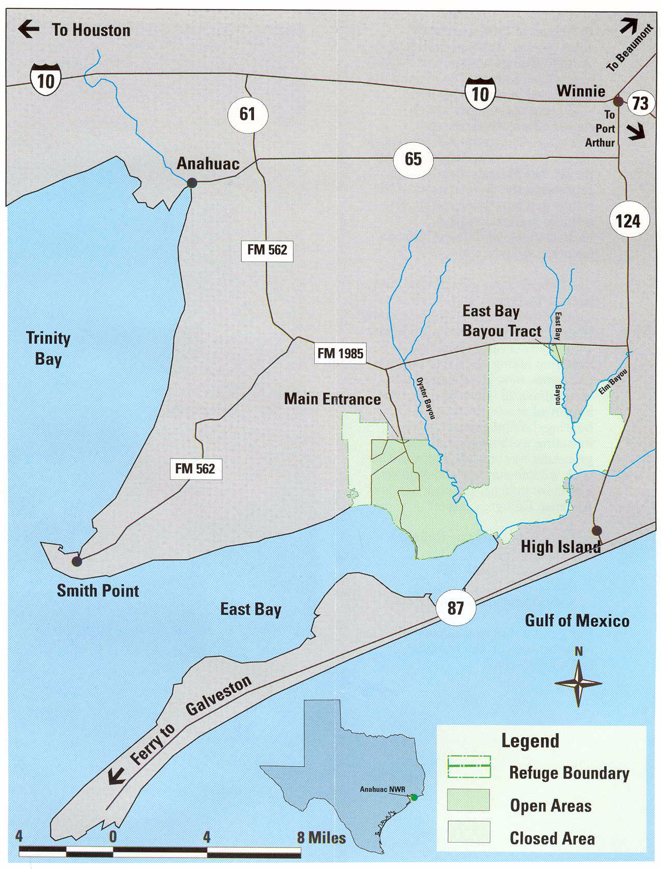 | 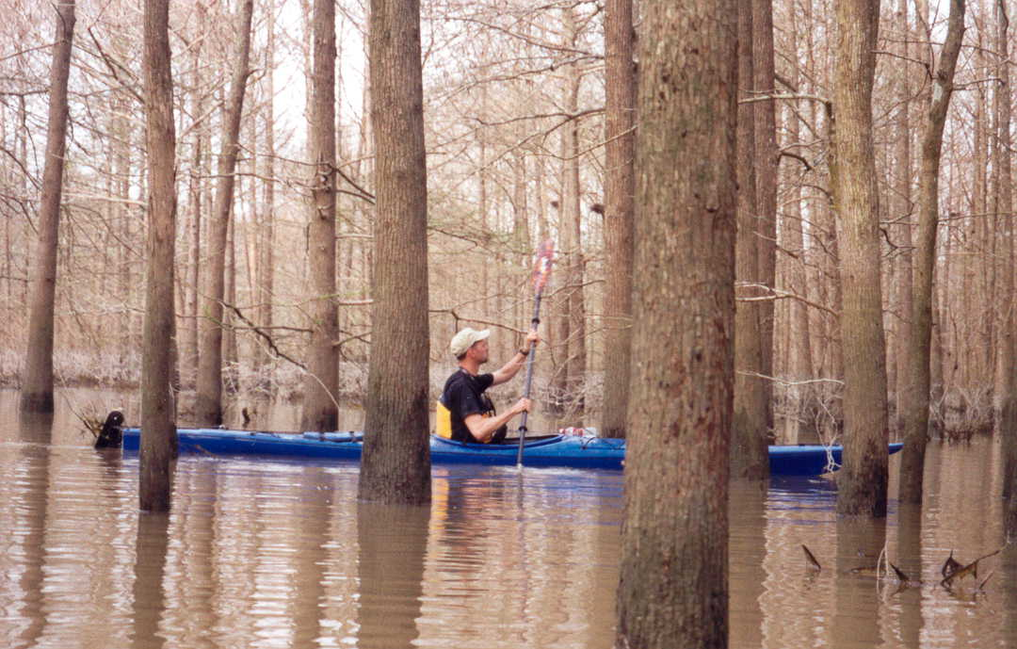  Left: Map of Anahuac National Wildlife Refuge, located east of Houston.  Above: Paul in his new boat enjoys paddling among cypress trees and heron nests. Photo by Robin Fortney

Mollie and I grabbed the following day for our big trip into Galveston. That meant crossing the inland coastal waterway over a high bridge to Bolivar Peninsula where we stopped briefly to walk the beach and enjoy the morning fog over the Gulf. Then we drove to the ferry for the trip to Galveston Island. We treated ourselves to a fancy lunch by the water and then we shopped for souvenirs and town clothes for dinner in Houston. Did you know the best and biggest Army-Navy supply store is found in Galveston? When we checked in with the guys later that day, they invited us to dinner at a little dive in Double Bayou. How can you beat burgers and pool with friends at a bayou juke joint decorated with canoe paddles labeled as shit-stirring sticks?
Our last day was filled with celebration and more adventure. First, we joined a public event celebrating the 100th anniversary of the National Wildlife Refuge System and the 40th birthday of Anahuac NWR, stuffed ourselves with steamed shrimp and met local supporters, and then Mollie and I took off for one last float trip. Tighe recommended that we paddle East Bay Bayou on the refuge. “You’ll see alligators, but they won’t bother you,” he said. It was a beautiful, sunny day and we happily put in and began paddling down the bayou toward the bay. Hackberry trees lined the bayou, and we saw lots of yellow-crowned night herons perched in the trees. We approached a little tributary and decided to explore it. I hit a hard object in the water as I paddled and, just as it occurred to me that there are no trees and maybe that was an alligator, a fish jumped up out of the water hitting my arm and scared the living daylights out of me! I suggested we return to the main channel, where my heart slowed down and we resumed basking in the day and the marshland. After another bend or two, I noticed an alligator watching us from the edge of the water. He eventually sunk underwater and I wondered how fast it could swim...Mollie and I resolutely proceeded downriver and then...whoosh!!!, the alligator came up and out of the water between our boats. Yikes!!! I began paddling with everything I had and I’m sure Mollie did, too, as she stayed with me. We settled down a bit as we put distance between us and the great beast, but we eventually we had to turn around and return to the car. When we got back to alligator bend, I saw his eyes and nose (was it waiting for us?) in the middle of the river. I called back to Mollie, “You’re on your own!” and began to paddle hard, but shallow. We passed the gatekeeper with paddles and boats and selves intact, finally returning gratefully to the put-in. Whew!
That would have been enough excitement for us, but the guys had another surprise in mind. When we returned to the refuge headquarters, Tighe and Paul asked if we’d like to take a powerboat out onto the bayou and enjoy the sunset. Ohhh, yes! So we speeded down and around the meandering bayous, through marsh grasses colored gold in the late afternoon light to the inland coastal waterway, where we stopped to watch birds coming in for the night. What a fabulous place! Paul’s plan was to take us into Houston for dinner at his favorite restaurant, so, after getting showered and changed and driving into Houston, we sat down at the Nit Noy, a Thai place, at 9:30 p.m. We had a wonderful meal and chatted and laughed until very late at a nearby microbrewery.
Now, THAT’s a great vacation!

DES MOINES RIVER by John Washburn

In mid-March, the Corps started letting more water out of the Saylorville dam. The water level rose up one and a half feet and the discharge was up from 200 to over 1200 cfs. Getting up the final channel before reaching the pool below the outlet is hard work. The fishermen have multiplied. Yesterday I saw two mink and one beaver. One of the minks and the beaver I saw from less than fifteen feet. I saw a mink several weeks ago as well. The geese have mostly gone off to colder fish. I did not see an eagle today (March 18), the first time in quite a while. Water temperature is around forty degrees. Fun. I only met one high-speed boater down near Prospect Park. Last Thursday was the first time I was able to put in at Prospect as the ice is melting.
SPRING UNFOLDS ON RED ROCK LAKE by John Pearson

March 15, 2003- Spring arrived this weekend in the form of record-setting 75-degree temperatures and sunny, blue skies. I scouted the south shore accesses to the Des Moines River and Red Rock Reservoir today. The Hartford Bottoms (Middle River) access was unapproachable by car due to deep mud. The South River boat ramp by Webb's Campground was open and accessible. There was a big ice jam on the upstream side of the Runnells Bridge, full of jumbled cakes of dirty, soil-encrusted ice, but flowing water between it and the left descending bank. The Sugar Creek access (straight north of Pleasantville) is in a marshy backwater about a mile from the main river channel- it was clogged with rotten ice and also populated with hundreds of Canada geese. The Mile-Long Bridge access at 120th Avenue was unapproachable due to mud along the last quarter-mile. Viewed from the Mile-Long Bridge itself, Red Rock Reservoir was completely covered with rotting ice with no leads of open water. I had hoped to float from Hartford Bottoms to Sugar Creek Marsh, but even though the river was flowing, you can't get there from here! I may try again tomorrow.

March 16, 2003- I returned to Sugar Creek Marsh today. Enough of yesterday's ice had melted to open a large lead around the southern edge of the marsh and, I hoped, a route to the river on its far northeastern side. A large sheet of slushy ice still covered the central pool of the marsh, but the edges were open water. My first kayak outing of 2003 began at 11AM when I set off from the sunken bridge over the swamped course of Sugar Creek (now inundated by the silty backwaters of Red Rock Reservoir). Isolated dead trees stood incongruously above icy expanses of water and marsh, relicts of fencerows and waterways that once lined pre-reservoir cropfields, which had in turn replaced the bottomland forests that had occupied the floodplain in pre-settlement times.

The water throughout the open parts of the marsh was very shallow, always less than a foot and usually less than six inches. The tips of my paddles were soon muddy and I felt a drag on the kayak most of the time. I even grounded on barely submerged mudbars a few times and had to pole through them or retreat by pushing backward into slightly deeper water. The deepest water was located along the edge of the melting icesheet. I skimmed along the edge and plowed through slushy lobes. At times my paddle would easily break through the rotten ice, other times would just glance off the frozen surface. In places, the open water was above a sunken ledge of ice. Paradoxically I could see heat waves shimmering above the ice and water even as I felt cold, convected air wafting onto my face.

Hundreds of Canada geese and mallards were feeding in the marsh and flew to nearby pools as I passed. The main waterfowl spectacle was a very large, very noisy flock of snow geese on a mudbar in the northwest part of the marsh (which I avoided approaching so as not to set off a panicked mass flight). I initially estimated over a thousand birds, but kept revising this upward as more and more flocks flew in from the north and spiraled down to join the one on the ground. Each time a new flock appeared in the sky, the two groups would call boisterously to each other. In fact, I quickly learned to scan the sky for another incoming flock whenever the noise level rose above the continuous background squawking. Although all of the honking sounds seemed to be only one word to me (roughly "Hey, hey, hey, hey!"), no doubt the geese understood more. Variation in the frequency, volume, and urgency of the collective yelling probably communicated messages ranging from general declaration of existence ("Here I am! here I am!") to excitement at being joined by cohorts ("Look, look, look! There they are! Here they come! Here they are! Hurrah!") to frenzy when disturbed into mass flight ("Run for your life! Let's get out of here!”).

Twice during my exploration (including once when a small plane flew raptor-like overhead), the main flock erupted into flight and circled the marsh before resettling onto their original mudbar- all accompanied by the wild, cacophonous screeching of thousands of high-pitched goose voices and a thunderous beating of wings. Only then could I see the whole flock and realize that its true number was closer to ten thousand birds. The flight eruptions were a visual feast as well - the immense flock flew in a tight, swirling, amoeboid fashion, speckled riotously with white and black. The black-and-white coloration of the flock changed kaleidoscopically due to the frenzied flapping of black-tipped white wings. the shifting interspersion of dark individuals among white ones, and the alternating sunlit and shadowed appearance of birds as they circled in and out of the axis between the midday sun and me.

I never did find a channel through the marsh to the river. Across the grassy expanse of the marsh, I could pick out the course of the river by the curving line of tall cottonwood trees lining its banks, but each sweep of open water dead-ended in bulrushes and smartweed before reaching the trees. One watery path looped past the flotilla of snow geese, but I opted not to disturb them by passing that way. Keeping a low vegetated island between the giant flock, and me I retraced my route circuitously back to the boat ramp.

April 12, 2003- I took a long paddle on Red Rock Reservoir, 14 miles round-trip from the Mile-Long Bridge to the dam and back. I looked forward to the calm water and aesthetic vistas of an evening paddle. Starting in mid-afternoon, however, that condition was still several hours ahead. Steady paddling transforms time into distance, so miles become a meter of hours.

Mile 1- Pelicans floating on Teter Bay were a startling white against bright blue water as I launched my kayak from the gravelly beach below the riprap of the parking lot. Motorboats roared away from the concrete ramp a short distance away, leaving a lingering stink of gasoline exhaust. Our paths quickly diverged as the motorboats zipped out to the center of the lake and I paddled parallel to the shoreline, but the sounds of the motorboats reached across the lake as if projected from amplifiers. Their wakes swelled past minutes later. After only a short distance, I stopped on shore briefly to peel off my jacket, which had become too warm. A pair of equestrians was watering their horses a short distance away. The horses were initially apprehensive of my landing, apparently unsure if I was human or some kind of sea creature come ashore. Their emotion quickly turned to curiosity when I emerged from the cockpit and stood up. Their riders walked the horses closer to satisfy their curiosity before saddling up and riding away.

Mile 2- Scattered serviceberry trees bloomed in the steeply sloping forest above the big cliffs at Elk Rock Point. They were absent from the lower, more rolling landscape underlain by soft shales as I approached from the west, but dotted the tops of the hard sandstone bluffs. I had come this way today in hopes of seeing the blooming serviceberries, whose profusion of white flowers at peak blossoming in favorable years can make the bluff top appear to be snow-covered in mid-April. I saw immediately that I was too early to see the full display today, but was relieved to know that I was not too late (requiring the wait of another year); a return trip next week is now in order.

Mile 3- I “threaded the needle”, paddling through the narrow sea cave where a block of sandstone had slumped away from the cliff. Unseen pigeons cooed eerily inside the cave and exploded in flight as I emerged on the far side. Waves sloshed and gurgled pleasantly as I paddled past a line of cliffs riddled with pock-holes, alcoves, and incipient sea caves. Ancient cedars leaned away from the crest of the cliff, reaping sunlight unreachable by the legions of taller, straighter oaks crowding the bluff top.

Mile 4- Whitebreast Bay stretched expansively in front of me, a mile-wide crossing where wind and waves are often the bane of rudderless kayaks, but the calm conditions today made for an easy effort. I pulled ashore on the far side and rested on a rocky beach. A trio of elderly fishermen in a small motorboat trolled quietly past and waved. Decision time: start the westward return trip (for a round trip of 8 miles) or keep going to the dam (3 more miles eastward, thus adding 6 miles to the journey)? The pull of unseen country spoke louder: onward!

Mile 5- The sun crept lower in the sky and brushed the landscape with evening shadows, the beginning of my favorite time to paddle. I rounded Whitebreast Point and saw the low gray line of the dam three miles in front of me. The lake becomes very broad at this end, over a mile wide. Waterfowl eschewing the narrower reaches congregate in this area. I glimpsed rafts of scaup in the middle of the lake and also spotted lone coots and loons. Pelicans had been all along the lake as scattered individuals since the start of my trip, but formed up in groups of a dozen or more here. Gulls- ringbills and Herrings- seemed more numerous, too.

Mile 6- The bluff flanking the dam on the south shore seemed no closer than it did a mile ago. Mountaineers speak of the deceptive effect of “foreshortening” when viewing distant landforms across vast open space, making things seem closer than they actually are.

Mile 6½ - Still no appreciable change in my perspective of the bluff. Was I just treading water? I tried to ignore the fatigue in my arms.

Mile 6¾- I was within a quarter-mile of the dam, but still it seemed far away. Checking my watch, I saw it was nearly 5:30PM. I paused to do some math in my head: 7 miles at 3 miles per hour means 2 hours of return paddling…add 2 to 5½ makes…7:30PM, which is sunset. Hmmm! I realized that I really didn’t have time to paddle up to the dam and touch it with my hand. I turned around and began paddling into the lengthening shadows.

Mile 10- I took a short, floating break in the middle of Whitebreast Bay, turning the kayak to face east toward the sunlit bluff on the receding shore. Sunlight and shadows competed for space. Broken boulders of buff sandstone littered the low shale beach where I had rested on the outbound leg, blackened here and there with patches of lignite. Lone pelicans glided low overhead, resembling small pterodactyls. A loose kettle of turkey vultures wheeled over the peninsula, looking for a night roost. I paddled off under the power of a second wind.

Mile 13- Abeam of Elk Rock Point once again, I paused for another break and admired the effects of the gathering sunset on the reddish, crenellated cliffs, the brilliant white serviceberries, and a red-pated vulture swooping below the shadowed crest. I heard whooping as a group of eight horse-riders galloped up a ravine and appeared suddenly at the bluff top. They were so absorbed in recounting their ride that they did not notice me bobbing conspicuously offshore. They regrouped and vanished down the trail, still chattering excitedly. I resumed my trek, the way home now a flashing, spangled pathway of light on gently rippled water in front of the setting sun. I passed turkey vultures assembling for their night roost on the shoreline where the curious horses had been.

Mile 14- The sun was kissing the horizon as my kayak grated ashore on the beach below the car. I stepped stiffly out of the cockpit and stood unsteadily on legs that had not stretched for 3 hours. My arms, shoulders, and torso ached from nearly continuous paddling. Next time, I thought as leaned on my paddle and gazed back across the water, the serviceberry will be in full bloom!

IOWA WHITEWATER COALITION NEWS by Nate Hoogeveen
What a cleanup! Despite the cold and snow, fifteen brave souls showed up on April 6 to help with the cleanup at and near Walnut Woods State Park. Thanks to everyone who came -- park superintendent Tim Gedler mentioned that such a cleanup had never been done along the riverfront, or at least not for a very, very long time.
We got all manner of bags, bottles, cans, and some larger junk like carpet, tires, pieces of automobiles, and a chassis of a wagon that physicist friends warned us was too large to balance on a canoe. We also got boulders (probably pushed there by ice) pushed off the boat ramp. Those who came worked extremely hard, and Tim was greatly appreciative, and says he hopes we'll return. I think we really helped make a place better.
At the meeting in Walnut Woods Lodge, Don McLaughlin of the City of Des Moines Parks and Rec showed up and gave us the latest. He told us he's brought staff from the engineering department and risk management to look further into the plans for the dams downtown. The city still needs to find funds (perhaps with our help) to get a preliminary design done. He's also working to get a grab cable above the Scott Avenue dam and better signage at both dams in the meantime, for safety.
Gerry reported on his road trip to Kidder Dam and Fargo where dam-to-rapids conversions have been done. He believes the Corps could refine this idea somewhat to make the dams work even better for paddlers.
Those present included Joanne and Mike Mendenhall, Deidre O'Neill, Chris Pedersen, Leonard Tinker, Carolyn Komar, Rick Deitz, Bruce Hinrichs, Gerry Rowland, Robin Fortney, Dick Howard, Dan Howard, Don McLaughlin, and myself (if I'm missing someone here... sorry). We took votes on whether to pursue becoming a more formally organized group. This idea was unanimously approved. Bruce Hinrichs was voted as treasurer, Gerry Rowland as Vice President, and I was selected as president. Greg Vitale (not present because he was attending a whitewater seminar in Missouri this weekend) was tentatively selected as secretary if he agrees to take the job. We agreed on membership dues of $10 per individual per year. There was a previous donation of $50 that I gave to Bruce. The new executive committee will hash out the group's formal structure (whether to become a 501(c)(3) non-profit or some other kind of tax status organization) at a future meeting. Bruce suggested we meet at the Paddlefest in Cedar Falls next month -- the full group can vote on whether to approve what we come up with. Anyone who wants to be involved with drafting our by-laws can contact me.
To sign up, see http://groups.yahoo.com/group/IowaWhitewater/.
WAPSIPINICON RIVER by Dick Howard
First things first: Rick and Lynn did an outstanding job arranging and organizing the weekend along with help from some of the other Skunk River Paddlers. Everyone said they had a good time and plan to make it an annual must-do trip.
Being one of the unemployed, I was able to be the first to arrive at The Red Oak Lodge Friday afternoon. I filled my backpack and hiked the half-mile back to the Lodge. I set up my tent a safe distance from the balcony and unlocked the doors and opened the windows of the Lodge. I went back to the parking lot for a second load. I haven't backpacked and usually camp out of the back of my truck so I don't own anything light. I was on my third trek when Lynn and Rick showed up. I think we got all the stuff they brought in one more trip to the parking lot. We decided to check the river and the put-in while it was still light so we drove to Waubeek and then Central City. The put-in was a bridge between the two towns and there was enough water.
When we were back at the Lodge parking lot, Bob Johansson arrived. Back at the Lodge, while Bob was setting up his tent, Rick began preparing soup. He was carefully following a written recipe sent by his wife then I tried to help. One can of beans was introduced into the pot without having been drained and rinsed. I didn't know. I hope there won't be any lasting side effects like lesions, tumors or pustules. We all ate the soup and it tasted great. Since it was getting dark we decided to take a walk and place a glow stick on the trail sign for those arriving later. There was a clear sky and bright moonlight. Good stuff!
Later back at the cabin. More people began arriving. Greg and Flo, Diane and David, Carolyn, Whitney and Dave, and finally Phyllis and Bill. All were one-trip backpackers, each carrying huge loads that would break the back, mind and spirit of a mere mortal. Each emerged out of the darkness into the bright glow of the Coleman lantern with dilated pupils and tiny beads of perspiration on their quivering upper lips.
I was to ascertain later the character of two of the individuals carrying what appeared to be equally heavy loads. One was carrying Tea and Soymilk, the other Beer and Alcohol. Values? Priorities? When I noticed people were fluffing their sleeping bags and that Flo was already asleep, I headed for my tent.
I left the fly off the tent so I could see the stars. Bill pointed out this was the wrong thing to do, as I would get dew on my lilies. I ignored him. He was sleeping on the balcony with the bats. The sky was clear and full of stars. There were many, many night sounds: barred owls, ducks and geese, a great horned owl, machine sounds, a siren and, just before daylight, coyotes. Then lots of bird sounds. More good stuff! The morning was brisk. Coffee has never tasted so good!
After everyone had breakfast and did what they had to do, we headed for the parking lot where we met David and his wife and Jerry and Elizabeth. We saddled up and headed for the put-in. Diane, David and Bob J were with me in my car. It didn't take them long to point out that I had turned left and should have gone right at the very first turn. They were all pretty sharp considering it was morning. We eventually got to the river. It gave the others time to get their boats down.
It was a short paddle to Waubeek where we were to have lunch at the local inn. Getting to the stop early was a plus. Watching tandem canoes and glass kayaks come through a rock rapids while drinking a cold beer is one of life's simpler pleasures. You never know what might happen. Lunch was a loose meat sandwich with chips for 2 bucks and a beer for 3 bucks. The entertainment was listening to complaints about paying 3 bucks for a beer and the aforementioned rock rapids. The entertainment alone was worth 5 bucks! Whoops! I almost forgot the entertainment and enlightenment to be found on the men's room walls, not to mention the phone numbers. What did the Elephant say to the naked man? Make that $5.50!
We headed down the river. There was enough water to paddle and not walk. There was a pretty steady current and little wind. We paddled into the Boy Scout camp's new lake from the river and also stopped and explored an old quarry that had been turned into a park.
We got to a point in our journey where the river had broken into several channels and some were blocked or dead ends.
Greg courageously took the lead and lead us through where he and Rick had cleared a path last Fall. One chute was fast and twisty and I was still trying to figure out what I had done wrong on the first snag I hit, as I careened off #3 and #4. I felt like a pinball. I tried to act in control as Diane was right behind me and was doing a lot better paddling than me. We stopped for a break. Lynn wandered off and came back with some ancient fossil treasure of crinoids, altoids, deltoids, or mergatroids. Bill forced me to eat chocolate.
On down the river, David was paddling in the front of Carolyn's canoe suddenly flanked by Lynn and Diane. They picked the topic of conversation. Poor David! I didn't see any blue herons, nor did I see the beaver activity that we've been seeing on the Des Moines and Raccoon rivers. The river bottom seemed to be mostly sand. The rocks and bluffs appeared to me to be a darker and almost wet looking limestone. When we got close to the Lodge you could see that it was on top of a bluff and a very beautiful sight from the river. We pulled the boats up on the riverbank for the night. This first day was approximately 14 miles.
The evening potluck was an epicurean delight of epic proportion. There was much feasting and jocularity. Late in the evening some had turned in and some were still on the balcony discussing many things. There were owls hooting in the distance, a somewhat strange hoot to my thinking, sort of a cross between a Barred owl and a Great horned owl. Dave was able to mimic it almost exactly. He kept them hooting for a very, very, very long time.
The sky was again clear. Conversation turned to wishing on a star. I understand that if you see a falling star and make a wish before it's gone the wish will come true. Dave wishes for world peace. Phyllis wishes for red socks. I was wishing I hadn't put my fly on, to keep my lilies dry, so I might possibly see a falling star and be able to wish they would go to bed. Bill again slept with the bats on the balcony.
Breakfast on day two was a Trangia festival. Boiling water has become a competitive sport. Even though I started early my 3 trips, carrying stuff to the parking lot, I missed the shuttle. I did meet Peter Komendowski in the parking lot, who had come to join us. He's a paddler from Waukon that Nate met last year in his travels. Dave Bell had to work so he and his wife weren't going to be with us, this the second day. Lynn, Carolyn, Phyllis, Whitney, Flo and David cleaned the Lodge and closed it up.
When everyone returned from shuttling cars to Anamosa we launched. It was another warm, sunny day. We saw deer, a pair of nesting eagles, one on the nest the other in a tree nearby. There were lots of ducks and geese and a redneck with a confederate flag. We had some wind and motorboats to add challenges but nothing that created a problem. Greg found us a well-marked site to take a break and snack and Rick documented everyone with his camera.
The river widened because of the dam and wind picked up the last mile or two so it was a little more exercise. I kept watching to see if Whitney would try to practice cartwheels or tricks with Dave's sea kayak, but it didn't happen. After taking out at Anamosa we packed up and some headed home. Day 2 was approx 6 Miles. Bob J and I and our boats got rides back to the Lodge parking lot. Some of us stopped again in Waubeek where Peter bought a round. Nate told me I'd like him! About 30 Harley riders joined us at the inn. We all got along. The streets were lined with boats and bikes.
I'd like to do it again next year!

LITTLE SIOUX RIVER by John Pearson

It’s May 10 and we are on the Little Sioux River: Robin Fortney in her solo canoe, Don & Kay Wall in a tandem canoe, me in my kayak. The river, here near its headwaters in Dickinson County, is scarcely more than a creek. Fortunately, recent heavy rains assure that our trip will not be one of dragging over rocky riffles; instead, I scan the put-in site at Twin Forks for signs of flood, but this, too, is a needless worry. (The USGS gauge at Linn Grove 50 miles downstream indicates a flow of 1000 cfs.) The gray sky and chill wind presage an approaching storm front scheduled to arrive in the afternoon, but we gaily float away from the Twin Forks Access shortly before 10 a.m. Cayler Prairie and Freda Haffner Kettlehole lay downstream between us and the take-out at Horseshoe Bend park some twelve miles away.
We pass quickly beneath the first bridge, where a man has stopped his pick-up truck to watch our departure. A riffle demands my attention and when I looked back after wrapping around a bend, the bridge is gone. Grassland sprawls across the landscape, unbrokenly green due to regrowth from a spring burn. My eyes are drawn to distant hillcrests and along the unfettered, rolling horizon between land and sky. Its utter treelessness feels strangely different than the view from other streams and I feel the relaxing expansiveness that only a prairie landscape can evoke.
As we enter the northern boundary of Cayler Prairie, a square mile of state-owned grassland with a native prairie preserve in its southwest quarter, we pass a Canada goose nest on a tiny island, seven huge brown eggs crowded into its straw-lined bed of downy feathers. The parents honk indignantly as they evade our approach and watch apprehensively as Robin pauses to snap a photo of their vulnerable nest. They fly swiftly back to the nest as we round the next bend, finding it undisturbed by our brief passage.
The botanical part of my brain notes that the grassland that we’re traversing is mostly brome grass (the true native prairie still lays ahead out of view); Emory sedge and canary grass lined the bank. However, negotiating a mile of river through riffles, meanders, sprinkling rain, and a blustery wind detaches me from the more clinical, scientific approach to the prairie that I have more typically taken during previous visits (land-based, car-delivered, job-related problem-solving as a professional ecologist). The river now engages senses and perceptions not required of a walking inspection, field trip, or data transect. Science and adventure, analysis and experience, reason and feeling are the ying and yang of a true naturalist, and it works for me.
The only man-made features on the prairie landscape loom into view as we near the preserve: huge pylons draped with leagues of power cable, all radiating from an electrical substation on the upland east of the river. Electricity is a vital part of our modern society, but maybe someday we will invent a way of transporting it across the landscape less obtrusively. As requested, Don and Kay are waiting for Robin and me under the first crossing of the wires over the stream. We regroup, then float a short distance farther to a landing on the right bank. Avoiding a patch of cocklebur, we step out onto a grassy lowland and climb to a low rise. We gaze southwestward at the native prairie preserve. Eskers rise ruggedly beyond a wet swale, still tawny with winter bluestem grass. Despite the lowering sky and cold wind, we set off toward the nearest esker, slowly weaving our way between sedge tussocks. Climbing the steep flanks of the esker, we suddenly find ourselves walking through thousands of pasqueflowers, their “Phyllis Diller” fruiting heads waving in the cold wind. Squeals of discovery of blooming flowers soon followed: “prairiesmoke,” “groundplum,” and “here’s a pasqueflower still in bloom!”
Now atop the esker, amid a square mile of roadless grassland, we can turn in place and see only rolling prairie for 360 degrees (or 720 or 1080 as I rotated again and again), bisected by the Little Sioux River where our boats lay hidden and marred only by the network of silent power poles marching across the eastern vista. A buffeting wind and intermittent drizzle add to a sense of remoteness from the ordinary places of everyday life. Although only a half-mile from a road, our arrival via the river let us indulge in the fleeting vision of a wild Iowa, of an expansive prairie province reduced now to a point. We stand at the center of the arc and gaze at a remnant landscape.
Feeling the press of unfinished traveling (one mile down, eleven to go), we return to the boats and relaunch into the river. Shortly downstream, a pair of blue wing teal jump from the water and fly swiftly away. Low bluffs studded with prairie bunchgrasses slip past. A fence across the river (the first of many that we will encounter during the trip) awaits us at the south boundary of the prairie preserve. We pass cautiously underneath and find ourselves floating through a pasture. A scattering of horses on the right bank regard us tentatively from a safe distance at first, but then band together and race down to the fence line for a closer look. The rumbling of their many hooves elicits a mocked call of “Stammmmmpeeeeede!” from someone in the group. The gang of horses stops abruptly at the fence and watches us curiously, eyes bright and ears collectively aprick, jostling with each other for a better view. Robin snaps a photo of their comical line-up as we drift out of their pasture.
At the far end of the pasture, a second fence (this one brushing the surface of the river next to our second bridge of the day) is too low to pass under and too high to pass over, forcing us to land on a small sandbar for a portage. Once past the bridge, a chunky black bird flies clumsily across the river in front of us from a willow thicket into a dense band of horsetails and cattails. I glimpse a short beak and patches of orange underfeathers before it disappears into the vegetation. A rail! Or maybe a sora? The secretive behavior of the bird, the inaccessibility of the bird book in fastened gear, and the pull of the river prevent further research.
We lunch on a small grassy knoll in the midst of a large pasture. As we settle in to eat, sleet begins to fall. Tiny iceballs accumulate on the dark fabric of my rain pants. Thunder rumbles distantly. I peer at the others, worried as trip leader that people could quickly become disspirited if they are wet and cold. Fortunately, everyone is wearing good raingear and no one seems discouraged. Although the sleet soon ends, the chill of inactivity moves us to resume paddling.
We proceed down the river and I began to watch for landmarks for the Freda Haffner Kettlehole preserve, where I want to take a second prairie walk. Light rain comes and goes several times. Heavily grazed, grassy hills (treeless except for widely scattered cedars in places) flank the river, sometimes close, sometimes farther away. Having approached the preserve previously only by car and foot, I worry about bypassing the prairie without recognizing it, but it is unmistakable when it comes into view at last. On river right, a forested hillside, the first woods we had seen since leaving Twin Forks, forms a dark beacon visible from over a mile away. As we round a final meander, a long, steep, grassy hillside opposite the forest rises up on river left, studded with tawny bunchgrasses just like the eskers on Cayler Prairie. The esker looks bigger and more impressive than I remember from previous walking visits.
We pull ashore on a sandbar, walk several yards across a bluegrass pasture, and slip under the preserve boundary fence. As if touched by a magic wand, the vegetation changes suddenly to native prairie: cordgrass in the slough, bluestems and porcupine grass on the slopes. A few steps up the hillside reveal blooming groundplum, prairie violets, prairie smoke, and bastard toadflax as well as more big stands of fruiting pasqueflower. We climb to the rim of the kettlehole and look down into the basin formed by its clasping arms. During the great meltdown at the end of the Pleistocene epoch, a sand-laden stream flowing under the rotting continental glacier here encountered a giant block of ice that had fallen from the frozen ceiling and was forced to diverge around it as an island; when the flow of water under the ice slowed, its passages around the ice block became clogged with deep sand, forming the two arms of the esker we now stood upon.
As on Cayler Prairie, our roadless approach and the extensive natural viewscape lend a mystique to the experience. Robin and I later spoke of how this landscape evoked a sense of “buffalo country,” by squinting at distant cattle on an open pasture skyline, we could easily imagine bison silhouetted on a prairie horizon.
After brief exploring and botanizing, we return to the boats. We are at the midpoint of our float trip and need to reach Horseshoe Bend before the approaching storm front. Thunder rumbles ominously as we resumed our paddling. The rain begins to fall in earnest, pattering aggressively on the surface of the river, and the lulls between rains become shorter. My recollections of the journey grow more impressionistic: a hillside seep on the right bank, festooned with thousands of bright yellow marsh marigolds; another herd of horses on river left; spotted sandpipers and a lone Franklin’s Gull (swimming incongrously in a wooded reach of the stream); a swimming muskrat that dives suddenly as we slip up quietly behind it.
I am counting fences across the stream and am up to nine when I lose track. Robin and I easily dodge them in our low-profile solo canoe and kayak, so we need to portage only once. However, the higher profile of Don and Kay’s tandem canoe forces them to portage several times. The nastiest one is on the upstream side of the Highway A34 bridge: low, barbed, and electrified. Both Don and Kay are zapped as they portage along the bank, Kay when she inadvertently touches the wire and Don when the metal gunwale at the stern brushes against the wire. In addition to the physical break in the continuity of the float trip by the Highway A34 fence, a psychological break in our experience of natural scenery occurs just below the highway when we encounter newly constructed houses on the banks and bluffs (with more promised ominously by a sign glimpsed from the river for a future “West Sioux Estates” subdivision). Fortunately, a fenceless, natural landscape resumes a short distance later.
Forest becomes increasingly extensive as we proceed downstream from the kettlehole and is continuous as we wind through the morainal hills upstream of Horseshoe Bend. In fact, trees now arch over the narrow stream almost everywhere. Bur oak and basswood on the hillside was now joined by silver maple, elm, hackberry, walnut, and boxelder on the floodplain. Some lean low across the stream, requiring us to duck. The crowns of others have toppled into the water, forming small sweepers to be avoided. Still others are sunken in the water and one of them snags Don and Kay’s canoe as they attempt to float over its tangled branches. After watching their unsuccessful struggle to extricate themselves by back paddling, and apprehensive about the canoe capsizing and delivering them into a strainer, I paddle back upstream and dismount on shore. Don tosses me a rope and I am able to pull them gently out of the mess. Just around the next bend, we encounter a large tree that has fallen completely athwart the river, blocking our passage. Robin has already scouted a portage around it, but upon re-embarking we discover a second tree blockade only a few paddle strokes later, requiring yet another portage.
The storm catches us as we struggle through the final mile. Lightning flashes brightly, thunder crackles with an angry edge, and the rain redoubles in intensity. The deteriorating weather and obstacles threaten a grueling finish to the trip, but Robin lightens our spirits with servings of cookies and good humor as we rest in a rain-soaked and timber-strewn portage. After a final reach of trouble-free paddling, the take-out at Horseshoe Bend Park comes into view and we pull out - tired, wet, but happy- in the pouring rain about 4:30 p.m.

UPPER IOWA RIVER by Phyllis Goodman
It was another gorgeous trip on the Upper Iowa with camping at Randy’s Bluffton Campground on April 25-27. We lucked out with clear, but cool weather for the weekend. The water level was ok to low. On our Saturday run from the Kendall County Park put-in to Randy’s Bluffton take-out (15 miles), there was considerable bottom scraping. Several quick, tricky bends kept us from getting too complacent. The trip ran 8 hours with two breaks for gourmet chow. Bill dazzled the fleet with squeezable peanut butter, a visual visceral view. Sunday was a shorter trip from Chimney Rock put-in to Bluffton Road bridge, about 4 hours with a generous lunch stop.
There were plenty of firsts for folks. Sometime after midnight on Friday, 13-year-old Burt saw his first shooting star. Nate Hoogeveen, Dick Howard, and Lynn Aldridge had been paddling nearby rivers for some days and reported seeing a mountain lion! The DNR confirmed that there have been sightings in this area. New paddling opportunities were made. Mary Bruce and Theresa Lawrence, two first timers to CIP, cold-called each other to get a ride up to Bluffton and wound up as future Lake McBride kayak buddies. Welcome to both paddlers, especially since they bring spare camping gear to share.
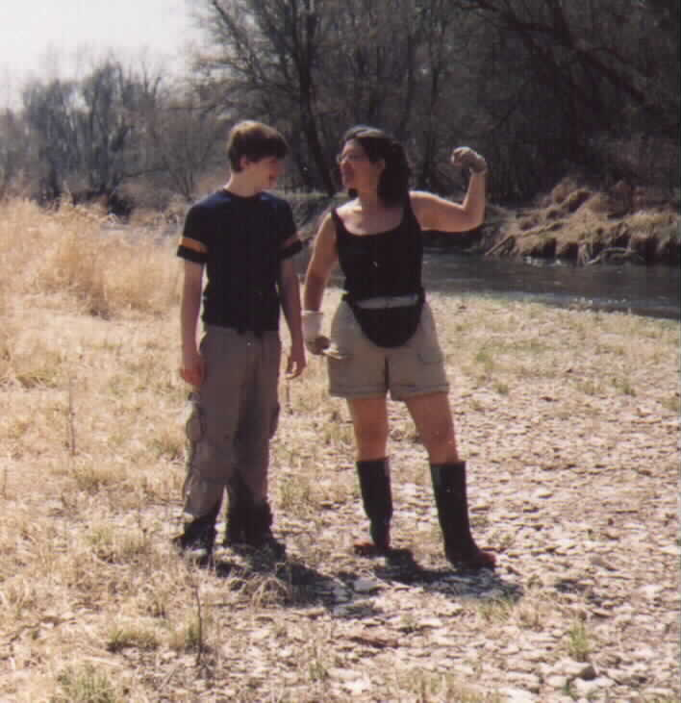  Burt and Phyllis show off their paddling arms. Photo by Dick Howard | 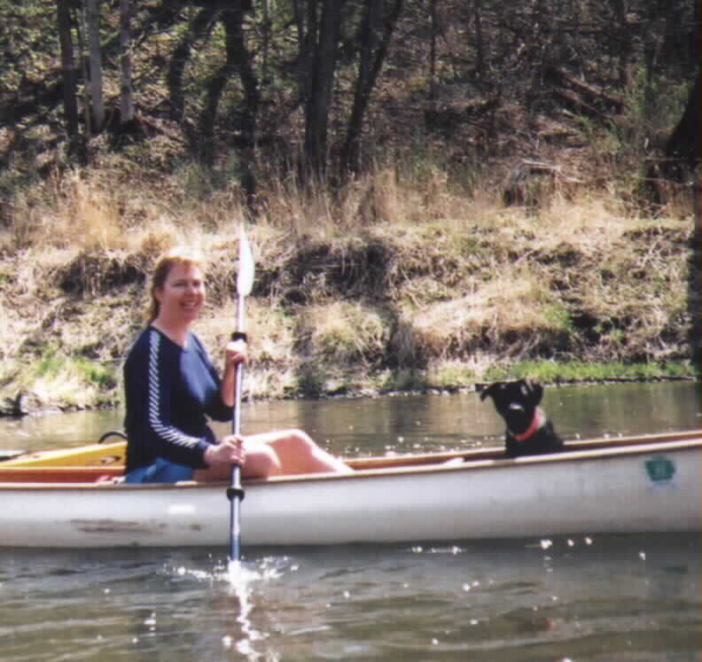  Lynn and Bennie the dog made good paddling companions. Photo by Dick Howard
The wildlife gave a nice show, as usual for the UI. Looked like muskrat love, from the number of critters seen swimming on the shore. Pairs of Canada geese seemed to nest around each bend. We did notice a group of three geese, but need to refer to an ornithologist for that one. The Dutchman’s breeches were glorious.
It was Lynn’s 40th birthday. There was birthday cake and Diane Meeker brought enough cupcakes to keep us in treats for two days. Lynn’s gift to herself was to save Benny, a wee black dog, from a future as Missouri interstate road kill but instead, will now live on an Iowa farm. And Benny got to go canoeing between locations.
Did I mention Robin Fortney was there? Well, of course!
Thanks to Bill Graham for taking the initiative on this one. We really can’t do much better for natural beauty than the Upper Iowa in early spring.
And more from Gerry Rowland:
I was in NE Iowa this weekend. We were 10 paddlers and 8 boats, 4 of them canoes. I took along my tow car. It was 200 miles each way. I got up to Cresco at about midnight Friday and slept in the Jimmy at the county Fairgrounds. The local police came by for a visit at about 2 a.m., but they were easily convinced that I was a harmless paddler. I got moving at about 6 a.m. with a little breakfast and a run through the lovely hills around the Upper Iowa River. I parked the shuttle at Bluffton across from high limestone bluffs and an old growth fir tree forest. I scouted out the area, marking the Chimney Rock access (mid point) and the put in at Kendallville, then met up with the group at Randy's campground, which sits on a bend in the river across from 200 ft. high limestone bluffs topped with an evergreen forest, just incredibly beautiful. It was good to chat with the paddlers, and I was amazed to hear that Nate and Dick saw a cougar on a remote stretch of the Volga River earlier in the week.
Our shuttle was pretty clever, with one paddler (Dick) bringing a trailer with gearbox. I took one other boat and four other paddlers so we got everybody upstream with just 3 vehicles. We were launched a little before noon, and found right away that the river was low. We soon were looking for the best way through the many riffles. As Diane pointed out, you could bounce off the bottom better if you "gunned" it. About 3 miles in, the canoes made adjustments so they were able to keep up. We enjoyed the high bluffs, the bluebells, eagles, geese, ducks, muskrats, otters, the evergreen stands, and the mild weather. After lunch we hit a rough patch of water about 8 miles in, and two kayakers were carried hard into the riverbank by fast water and capsized, but they were ok except for a lost camera.
It was 7 pm by the time we were done. Just as we were starting to fade, we came on the Chimney Rock formation, 200 ft. high with the cliffs weathered into long vertical columns. This is magnificent scenery, and I was glad I had made the trip. We were all glad to get to the campground at Bluffton, about 16 miles per the GPS. I drove back to Des Moines, so I missed the CIP birthday party for Lynn. I have to tell you that Lynn had the cutest little part-lab puppy that proved to be an excellent companion and a natural swimmer.

ABOVE RED ROCK & BELOW RUNNELLS by Steve Parrish

Steve Parrish and Bob Johansen used an overcast Sunday May morning to paddle the swollen waters of the Des Moines River. Because the floodplain was indeed flooded, half the challenge was to get to the put-in. Our first attempt to access the boat ramp from the west was foiled because the road was flooded. Finally getting there from the north, we found the ramp to be in the middle of a flooded field with surprisingly busy wave action. The actual winds were less than 15 mph, but something was stirring up a soup of confused water. We were glad we had decided to bring our bigger sea kayaks.
As we paddled towards the main channel, we were fascinated by how flooded the area was. We saw no signs of natural shores; just water lapping up to woods and fields. We’d paddle through what we assumed were cornfields then pass a copse of trees. Bob is sure somewhere along the line we ended up in the main channel. I’ll have to take his word for it. We had so much flotsam it was hard to tell, especially when bushes and treetops would pop up out of nowhere.
The trip out was surprisingly choppy. At points, there were rollers up to 2 feet. All we could guess is that the force of the main channel pushing water down at a high rate caused reflection into the shallows, putting backpressure on the floodplain. Add to this an upwind and we ended up with some fun waves pushing at us towards upstream! Once out in the main channel, things calmed down, the sun came out and we were in paddlers’ heaven.
An indication of how full the river system was that day is that most of our paddling involved doing a crossing from one side of the river to the other. On a typical August day, crossing the Des Moines River is a matter of pushing off, paddling 10 stokes and being on the other side. An equally good indication of the swollen river is that we had to work at finding our way back. Meandering among tree copses, cornfield and side streams required us to use visual markers to find our way back. We expected the paddle back upstream would be the hard part of the trip. But, with tail winds and waves, the return was easy.

LIZARD CREEK by Steve Weliver

On Sunday, May 18, the river gauge on the Lizard showed 6.175 feet. Ben, Ryan, Leonard, Lyle and I met at the take-out. Lyle and I had play boats and opted for the short run with Leonard while Ben and Ryan did the 15-mile leg. The scenery was great...deep cut, wooded valleys, lots of granite boulders, many riffles. Lyle and I played at most every feature, easy surf and eddy lines, rock spins, nothing spanky. In fact, we putzed around so much that Ben and Ryan caught up to us. They did 14 miles to our 4. So all 5 of us did the last mile together. Total time was about 4.5 hrs. We had a good time!

LITTLE CEDAR RIVER by Steve Weliver and Nate Hoogeveen

I've been scoping out the boulder rapids, looking for a play spot in Chickasaw Park on the Little Cedar River. Last week after hearing about it from Nate, I ventured up there. Flow
was in the 600 cfs range. It was a nice 50 yd long rapid with waves, pour-over rocks and pushy water. It'd be great fun for those who want to run rapids. The only danger I saw was the obvious hydraulic from the remaining portion of the low-head dam river left and the bump/grind/foot-pin potential for the swimmer.
Today (May 14) the level was in the 800 cfs range. It was much more fun and challenging looking. The waves were more numerous and bigger, some juicey holes dotted the edges of the run and there were no eddies from which to catch the waves. You'd have to catch them on the fly.
The potential to create one or two fantastic play-waves here is enormous. The Iowa Whitewater Coalition should contact Chickasaw County with the proposition to create better river access for paddlers and reposition the existing boulders to facilitate paddling through the pinball like rock garden (which will have a secondary effect of creating a play wave).
For anyone thinking of paddling there...avoid the left half of the river - that's where the low head dam hydraulic lives. The rock rapids is on river right and should be easy to boat scout.
Adds Nate: To add a little bit to this, I've seen these Chickasaw Mill rapids when it was below 200 cfs, also. The rocks are all rounded and pretty friendly, so you'll get a good thwacking if you swim, but wouldn't get cut up. Let me echo the foot-entrapment hazard: don't try to stand it these rapids because the entire bottom is boulders, and there are a thousand places to get a foot stuck. Keep your toes where you can see them if swimming, downstream and in front of you. Butts bounce off rocks - they don't get stuck. And, again, avoid the ugly hydraulics on river left, which is easily avoided by entering the rapids on the far right. I ran it at 850 cfs, and I think that 800-1000 cfs range is what you want to look for.

CEDAR RAPIDS’ 6th STREET WAVE by Steve Weliver

Update....had a very little time but also had a VERY BIG urge to see what the RR Wave was like at 4000 cfs...in my Air 55 - see http://sweliver.home.mchsi.com/rrwave.html. Never could catch it in other boats. Others boaters had only caught it momentarily...but tonight in the Air...I shredded it...Be forwarned - this is a low head dam...scout it first. The center section is “down” and can be run at all levels - left or right is the classic boil. I’ve seen so-called ww gurus CRY getting caught in the surface boil of such tiny pour overs so...All cautionary crap aside... when I caught this wave I knew I was in for a ride...fast, hard carves...WOW. After a year of attempts (in other boats) and now I catch it I was merely riding it out for the enjoyment. It’s just a flushy wave but next time we’ll be experimenting more. Help yourself to the Waterloo/Cedar Falls WW Experience

MIDDLE RACCOON RIVER by Robin Fortney

Bob and Dick and I enjoyed an Easter paddle trip. I had hoped to get on the Middle River in Madison County, but the water level was still too low. So, thanks to some advance scouting by Dick, we enjoyed a cool holiday on the Middle Raccoon River. We put in at Lenon Mill Park in Panora and floated down to Big Bend boat access upstream from Redfield. Trees were barely budding out, but the serviceberry trees were beginning to flower. Herons and eagles accompanied us. We stopped mid-day for our Easter celebration, which included sandwiches enhanced by rum with oatmeal cookie chasers supplied by Father Bob and the requisite chocolate offered by Dick. Since the air and water were both cool, we kept up a brisk pace after lunch. Bob hosted a warm-up/dry-out event at his place afterward and supplied Casey’s pizza for dinner. Thanks, friends!
On Saturday, May 3, I returned again to the upper stretch of the Middle Raccoon with Mollie, Lynda, and Dick. The river level was up, and it made travel easy and fun as there were standing waves at almost every riffle. This was to be a cleanup trip, but there wasn’t much trash to be found. We pulled out a drum after scaring off a sunning snake, a tire, sled, and lots of pop bottles and cans. It’s a relatively clean stretch, but there is a planter sitting in the middle of the river that will take a winch to pull out. We kept our strength up during the day with a big bag of chocolate chip cookies made from Lynn’s fancy chicken eggs.

Continuing the river cleanup theme, I’d like to share a song with you written by Sue Hotovec (and tweaked a bit by me) after one of last year’s river cleanup events:

THE 12 RIVER CLEANUPS
(Nature Version By Sue Hotovec; revised by Robin Fortney)
(Sing to the tune of “On the First Day of Christmas My True Love Gave To Me”)

On the first river cleanup the river gave to me
a bench seat from a '65 Ford

On the second river cleanup the river gave to me
2 broken crocks
and a bench seat from a '65 Ford

On the third river cleanup, the river gave to me
3 rusted bed springs
2 broken crocks
and a bench seat from a '65 Ford
On the fourth river cleanup, the river gave to me
4 oil drums
3 rusted bed springs
2 broken crocks
and a bench seat from a '65 Ford

On the fifth river cleanup, the river gave to me
5 tractor tires
4 oil drums
3 rusted bed springs
2 broken crocks
and a bench seat from a '65 Ford

On the sixth river cleanup, the river gave to me
6 beverage bottles
5 tractor tires
4 oil drums
3 rusted bed springs
2 broken crocks
and a bench seat from a '65 Ford

On the seventh river cleanup, the river gave to me
7 white tail deer tracks
6 muskrat den holes
5 tractor tires
4 oil drums
3 rusted bed springs
2 broken crocks
and a bench seat from a '65 Ford

On the eighth river cleanup, the river gave to me
8 wild roses
7 white tail deer tracks
6 muskrat den holes
5 dragonflies
4 oil drums
3 rusted bed springs
2 broken crocks
and a bench seat from a '65 Ford

On the ninth river cleanup, the river gave to me
9 sunning turtles
8 wild roses
7 white tail deer tracks
6 muskrat den holes
5 dragonflies
4 plovers nesting
3 rusted bed springs
2 broken crocks
and a bench seat from a '65 Ford

On the tenth river cleanup, the river gave to me
10 great blue herons
9 sunning turtles
8 wild roses
7 white tail deer tracks
6 muskrat den holes
5 dragonflies
4 plovers nesting
3 marsh mallows blooming
2 broken crocks
and a bench seat from a '65 Ford

On the eleventh river cleanup, the river gave to me
11 eagle sightings
10 great blue herons
9 sunning turtles
8 wild roses
7 white tail deer tracks
6 muskrat den holes
5 dragonflies
4 plovers nesting
3 marsh mallows blooming
2 fishermen
and a bench seat from a '65 Ford

On the last river clean up, the river gave to me
12 rainbow trout
11 eagle sightings
10 great blue herons
9 sunning turtles
8 wild roses
7 white tail deer tracks
6 muskrat den holes
5 dragonflies
4 plovers nesting
3 marsh mallows blooming
2 fishermen
and a river running free and clear.

CREEKING IOWA by Mike Modlin

The first weekend in May had been on the damp side. On Sunday, bored watching the rain come down outside, I called Dave Beason and asked if he wanted to take the boats out. The now bank full North Raccoon didn’t look like much fun, but we talked and thought maybe the First Descent down the Voas Conservation Area creek in Dallas County was in order. Four inches of rain had raised the often dry creek to, for us anyway, a challenging level. We shuttled the RPMs the ¾ mile around to the top of the creek, found a reasonable place to put in, and prepared for the considerable drop. Bank full and twisting down the valley around tight corners at a good clip,. Logs in many places blocked the rocky stream. Get wet? Yes, we did, and more than a few portages were necessary, but they resulted in a bag of morel mushrooms! We took out at the lower road an hour and a half later, tired, but glad not to have lost the afternoon.

PADDLING MISSOURI by Robin Fortney
Did you know this year is the 35th anniversary of the National Wild and Scenic Rivers Act? I celebrated by paddling one of the first rivers protected under this legislation, the Eleven Point River. It meanders through picturesque Ozark Mountains of southeast Missouri. The river cuts its course cuts through steep bluffs and forested valleys. Springs pouring from dolomite bluffs or rushing up from a vast network of underground flow systems provide a continuous source of water. Alternating stretches of rapids and deep clear pools wind around moss-covered boulders and shading bottomland hardwood trees. River birch is abundant along the shore, and aged sycamores lean out across the river from the shoreline. The Eleven Point is a relatively easy river (Class I and Class II, with a couple of Class III chutes on the International Scale) requiring intermediate experience. Snags, trees and root wads still remain the most dangerous of all obstacles.
When I paddled this river two years ago, the water level was low, the spring-fed river was absolutely clear and two others accompanied me. This time, the river was up quite a bit due to heavy rains and more turbid, and I had 26 friends with me. We were prepared to camp for four days, paddling the 19 miles from Greer Access to Riverton.
The drive from Des Moines took about eight hours, and we grouped up at the Greer Spring boat ramp on the morning of May 18. My boat was filled with camping gear, food and water, and felt heavy and unmanageable at first. Thankfully, the high water level made the river easily floatable. Our first day was overcast and cool, but I was on vacation and enjoying one of America’s rare wild rivers. We took our time, easing around rocks and strainers and through Mary Decker Chute, a line of large boulders placed in the river by lumbermen years ago. By late afternoon, we arrived at the designated float camp (there are several float camps along the 44-mile stretch of protected river). We set up tents, raised tarps over a couple of common kitchen areas, scouted for firewood and found the pit toilet. We would spend two nights here.
Our second day was spent on land. Some of us active types set off on a hiking expedition, covered from bow to stern to protect against poison ivy, ticks and stinging nettles. We hiked along the river, through the woods and eventually up the bluff. It started to rain after an hour or so, making the rocky ledge slick. Wee eventually turned around and then goofed off until dinnertime, enjoying a late bonfire. On the third day, we resumed paddling, stopping along the way to explore Turners Mill, Whites Cave and do some birding in the back water areas. We arrived at Horseshoe Bend Float Camp, a big area that allowed snorers and non-snorers to separate. Folks were in vacation mode and we took time to explore the large spring and former mill and identify flowers and birds.
The big excitement of our final day was running Halls Bay Chute. Bob, Mike, Dick and I arrived first, stopping on the island that separates the river (so it gushes over a big rocky ledge on the right and makes a snaky chute on the left) so we could scout the options. We determined a path and then jumped back into our boats to enjoy the rush of Class III water over the ledge. We decided to hang loose and wait for the rest of the group to arrive – the rocky shore of the island is a great spot for watching the action. It took some skill to ferry back upstream and cross the eddy line where the waters come together. The volume of water made for lots of fun and we wasted a good hour there.
The Eleven Point trip was soon over and we packed up for the drive north for three additional days on the Big Piney River. The Big Piney runs north and it was weird to paddle “up” a river. This area is also gorgeous and each section is different, from the intimate, meandering, full-of-chutes, tree-overhung upper stretch to the wide lake-like stretch below. The highlights for me included seeing my first prothonotary warblers, Louisiana water thrushes and spotted gar.
There’s more to be told, but you should make your own memories. I highly recommend that you visit the Mark Twain National Forest of southeast Missouri and paddle the exquisite rivers running through it.
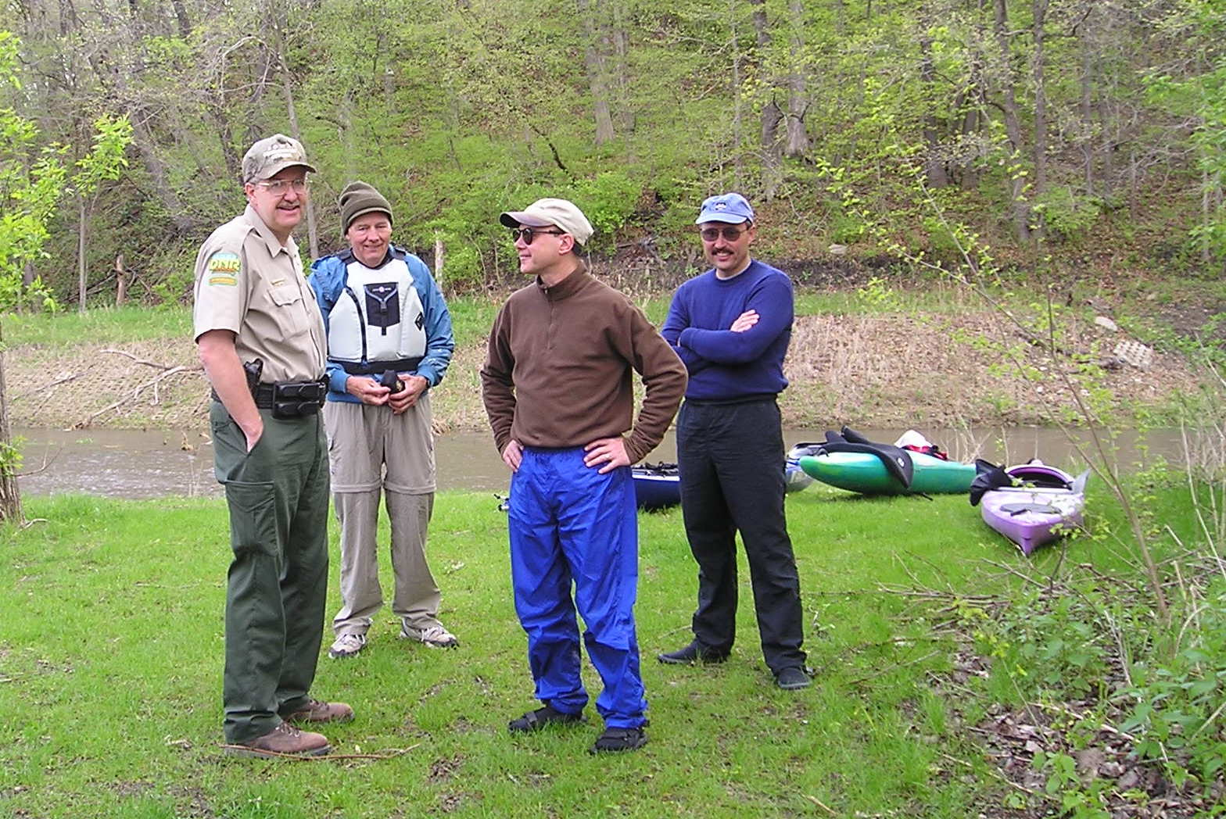  Don Wall, Dave Kraemer, and Rick Dietz chat with Iowa DNR’s Bill Fribley about boat registration requirements. (photo contributed by Rick Dietz) | REMEMBER TO REGISTER YOUR BOAT  Boat and personal watercraft owners are required to renew the registration of their vessels by April 30, 2003. Registration fees vary depending on the size of the vessel and are paid to the county recorder in the county where the owner resides. Failure to display current registration is a simple misdemeanor. Iowa’s recreational boating activities continue to grow each year. Registration fees are used to support Iowa’s boating enforcement and safety program.

GOOD GEAR TO BUY

Valley Skerray Sea Kayak 17’ by 23” for sale. A forgiving (seagreen) plastic kayak that can hold a lot of gear best for use on lakes or big rivers with a lot of upsweep to the bow and stern for when conditions turn rough. It weights about 55 lbs. $725 or best offer. Ames area. Contact Greg at vitol_g@yahoo.com or 515-663-9251.

Notes from Canoesport Outfitters in Indianola:
Thanks to all of you who took advantage of our new Greater Iowa Paddlefest format on May30-June 1 and enjoyed quality instruction from THREE ACA certified instructors, including a Certified Whitewater Instructor. We received a lot of compliments on the Symposium style format, which allowed us to focus on quality instruction. And many people applied their $21 fee to purchases at the store and participated for free and received a free T-shirt besides. (The Inland Sea Kayak Symposium in Bayfield charged me $150 per person when I attended last year and the instruction wasn't any higher quality than what we had at Paddlefest.)
Whitewater clinics and Women's Clinics were the most popular on Saturday. Our Friday Red Rock Tour participants had a wild ride with the high winds kicking up 4' - 6' waves. Our two guides had a great time surfing some of the big waves.
Thanks to all the volunteers who helped guide trips and kept things organized. It was definitely the best Paddlefest CanoeSport has had.
Paddlefest 2004, June 5th and 6th
Mark your calendar for next year's event. We're already making plans for a bigger event with more instruction. Expect the possible addition of slide shows, more speakers, more reps, and more fun.

Deals On Whitewater Boats

We are selling off our whitewater kayaks at some fantastic deals. Local whitewater boaters have chosen other retailers as their place to buy boats, so we have little choice but to discount what we have and stop carrying them. We will be between 20% and 35% off on all whitewater kayaks in stock until they are gone. This includes Wave Sport, Riot, and Dagger whitewater boats. We have the Siren, Boosters, some Transformers, and RPM's.

CENTRAL IOWA PADDLERS
Newsletter Subscription Information

Formed in March 1997, Central Iowa Paddlers is an informal organization started by and for people who find enjoyment and relaxation in the sports of canoeing and kayaking. The group's mission is to share information, promote recreation opportunities and paddlesport safety, and encourage care of our aquatic resources.

For a $10.00 annual fee, each subscriber will receive:

- Club newsletter in March, May, July, and September
- Subscriber list
- Schedule of paddlesport events

Since this is a cooperative organization, subscribers and friends are encouraged to share information about trips taken, lessons learned, equipment, safety, access, outfitters, eats, etc.

Scheduled and pickup trips are encouraged. If you want to lead a trip, please provide the following information to participants:

- Identify the stream section or lake
- Date(s)
- Meeting time and place
- Your name and phone number
- Class of river, or difficulty, if applicable

To put information in the newsletter, submit a notice to the Newsletter Editor, Central Iowa Paddlers, 688 Polk Boulevard, Des Moines, IA 50312. Deadlines are Feb 15, Apr 15, Jun 15, and Aug 15. Use the subscriber list to contact people about spur-of-the-moment trips. The Editor can forward trip information to members having an email address. Contact the Newsletter Editor at 515-277-1763 if you have any questions.

To subscribe, complete the form below and send it and annual fee of $10.00 to the Central Iowa Paddlers, 688 Polk Boulevard, Des Moines, IA 50312.

SUBSCRIPTION FORM
Name

Street Address

City, State & Zip

Day & Eve Phone

Email Address

List paddle sport
interests

SUGGESTED PADDLING TRIP SUPPLY CHECKLIST

Paddling
 | Canoe/kayak/paddles |  | Rain gear
 | PFD/Life Jacket |  | Extra set warm clothes
 | Hat/sunglasses |  | Snacks
 | Water shoes/camp shoes |  | Frisbee, hacky sack, cards, book, etc.
 | Sun screen/lip balm |  | Flashlight/headlamp/batteries
 | Water bottles |  | Waterless hand sanitizer
 | Toilet paper |  | Multi-tool/pocket knife
 | Camera |  | Whistle
 | Health insurance card |  | Insect repellant
 | Leather gloves/old boots |  | Journal/pen
 | Small ice cooler |  | Boat registration (if required)
 | 50 feet of rope |  | Extra set of car keys
 | Dry bag(s) |  | First aid kit
 | Handkerchief |  | Lunch/beverages (no glass)
Camping
 | Tent |  | Camp stove/extra fuel
 | Groundcover |  | Matches/lighter
 | Sleeping bag |  | Food items
 | Mattress pad |  | Cooking utensils
 | Duct tape/bungee cord |  | Water cans and/or water filter
 | Zip ties |  | Binoculars
 | Zip-lock baggies |  | Plant, animal and bird ID manuals
 | Reusable dinnerware |  | Biodegradable soap
Toiletries (add your own)
 | Toothbrush/toothpaste |  | Deodorant
 | Wash cloth/towel |  | Dental floss
 | Soap/shampoo

Remember: Be prepared to get wet, scratched and sunburned. If you have the proper gear, all weather is good weather for paddling.
CENTRAL IOWA PADDLERS - 2003 SCHEDULE OF EVENTS

Participants should contact the trip coordinator ahead of time for trip details and in case river conditions or plans change. Take rain gear, extra clothes in a dry bag, plenty of water and snacks, hat, sunscreen, PFD, and extra paddle.

Wednesday’s, May 14-September 10, Ames Peterson’s Pit
Paddle these former sand and gravel pits from 6 to 9 p.m. For more information, contact Rick (rsdietz@yahoo.com or 515-232-1484) or Greg (vitol_g@yahoo.com or 515-663-9251).

Saturday, May 24th, Des Moines River clean-up POSTPONED
We've partnered with the Ames Youth and Shelter Services and Seven Oaks Recreation for a clean-up between Boone Waterworks and Hwy 30. The clean-up will include the Waterworks and River Bend Access areas. Contact Rick at rsdietz@yahoo.com or 515-232-1484 or check <http://skunkriverpaddlers.tripod.com> for more information.

June 1-8, Maquoketa River
Join us for any or all of a weeklong float trip from Backbone State Park to Green Island. See http://www.iowadnr.com/volunteer/aware.html for more information.

Saturday, June 7, Watershed University
See article on page 1.

Thursday, June 12, Des Moines River

Meet at Birdland Marina in Des Moines at 5 p.m. We will shuttle cars to Sycamore Access. The float will last 3-4 hours, possibly ending after dark. Bring light. Contact Bob at johansen.bob@principal.com 515-280-7155 (h).

Saturday June 14, South Raccoon or Middle Raccoon
This 4-5 hour trip will depend on where there is water. We will meet at Bob's at 9 a.m. and end there for a picnic (burgers, brats and beans will be provided – if you want anything else, bring it). For details, contact Dick (515-996-2579 or rhow@dwx.com) or Bob (515-480-8299 or fatherrobt@yahoo.com).

Wednesday, June 18, Raccoon River
Meet at Des Moines Water Works Park boat ramp at 5 p.m. We will shuttle to Walnut Woods State Park. Trip will last 3-4 hours with one break for a snack. Contact Bob at johansen.bob@principal.com or 515-280-7155 (h).

June 21-22, West Fork of the Des Moines River
Contact Gerry at gerryr@netins.net or 515-281-7513 for more information.

June 28th, Timber City Adventure Race
A Triathalon with canoeing, biking, and running. Contact the Maquoketa Area Chamber of Commerce, 1-800-989-4602 or see http://www.maquoketachamber.com/html/adventurebrochure.htm.
Friday, July 4, Red Haw State Park
Join in the fun or watch the Skunk River Paddlers defend their title in the cardboard boat races. And don't miss the July 4th events in Chariton. For information, contact cityhall@lucasco.net.
For details, contact Rick at rsdietz@yahoo.com or 515-232-1484.

July 12-13, Des Moines River
Canoe Van Buren County – stay tuned for details.

Saturday, July 19th, Iowa Games Canoe & Kayak Competition at Gray's Lake. See http://www.iowagames.org/summer/CanoeKayak.asp

July 26 to August 2, River Rumble – Mississippi River
This annual week-long canoe/kayak trip will start in Savanna, IL and end in Burlington, IA. The distance traveled each day will be about 20-24 miles. Cost is $150, which includes shuttle for you and your boat. Contact Bob (515-247-5912 days or 515-964-7671 evenings) for details and signup information.

Saturday, August 9, Des Moines River
Join us in Des Moines for the Almost Full Moon Paddle & Potluck. Contact Julia at 515-282-4301.

Saturday & Sunday, August 16-17, Cedar River
We will float Palisades-Kepler State Park to Sutliff on Saturday and Cedar Bluff to Rochester on Sunday. The Palisades are beautiful. If water levels are right, we should be able to paddle upstream from the park and get up close and personal with the bluffs during our spare time. For details, contact Nate (515-256-7026 or journate@yahoo.com) or Dick (515-996-2579 or rhow@dwx.com).

August 22-28, Isle Royale
Sea kayak and camp on the south shore of Isle Royale. For more information, contact Steve at sbparrish@mchsi.com. TRIP FILLED.

Saturday, September 6, Des Moines River
Join the River Bend Neighborhood Clean-up Day by helping us clean the riverbank from Prospect Park to Second Avenue Bridge. Contact Julia at 515-282-4301.

September 20-21, Big Sioux River
For more information, contact Nate at journate@yahoo.com or Robin at rbfortney@midamerican.com 515-277-1763 (h).

September 27, Brushy Creek Lake
All paddlers are welcome to participate in this Fall Color Cruise and Builders Show. Boat builders will be specially honored. For more information, contact Jim (515-332-2069 or jdodd50@hotmail.com) or Rick (515-2323-1484 or rsdietz@yahoo.com).

September 27, Des Moines River
Des Moines Rowing Club Regatta - volunteers needed - contact Julia at 515-282-4301.

Saturday, October 4, Des Moines River
Join us for a float trip from Boone Waterworks to the Highway 30 access. Contact Don at 515-465-9368 or river41@aol.com for more information.

November 12-15, Missouri River Float and Bike Ride
This is a paddle & pedal trip with motel camping. We will float about 20 miles from Portland to Herman and then bike the Katy Trail. For more information, contact Bob at 515-964-7671 (h) or 515-247-5912 (w).

